1. Start Library.exe

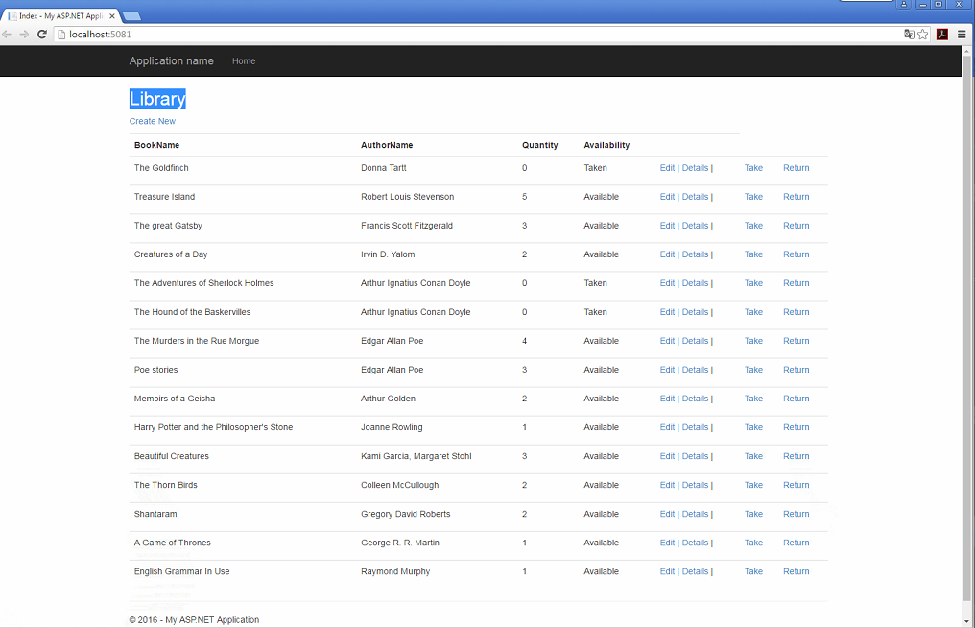2. After starting the program opens the web - page of the Library

3. On the home page is a list of books with the latest information about the availability and number of copies.

4. To add a new book - click on the “Create New” link

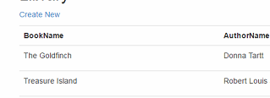

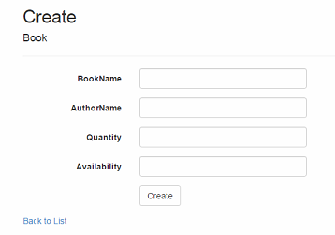5. When you go to page creation, opens a form to fill in information about the new book. After entering all the data, press the button “Create”. The data will be entered into the database. To return to the main page, click “Bask to List”

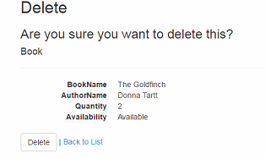6. To remove a book from the library - then click Delete. A dialog box will be displayed where all the information about the book and confirm the deletion.

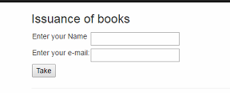7. To take a book in the library, click on Take. After data entry, the book is assigned to you. Date of taking the book is entered automatically. Identical has a function return.